Introduction

The game *Dante’s Inferbo* was developed for entertainment purposes with a unique personal storyline that was designed with our circle of friends and cohort of seniors in mind. It was also designed with enjoyable gameplay that can be played by users of all ages. The simple controls and basic concepts allow players from very young ages to be able to play, but the harder, skill-based levels that appear at the end of the game will interest older and more experienced gamers. The game contains slightly graphic imagery in the form of the health monitor, but it is comical enough that it should not disturb many children.

The main protagonist character, Max, was attacked by a giant piece of bread, and his computer was stolen. In the real world, our friend, Max, is an odd guy with a strange phobia of white bread, and a strong love for computers. The game revolves around him descending into the depths of his own personal version of hell in order to retrieve his computer. This involves him traversing the internet and other locations, and fighting internet trolls and other such enemies. The game is about moving around the levels in order to advance to the next room.

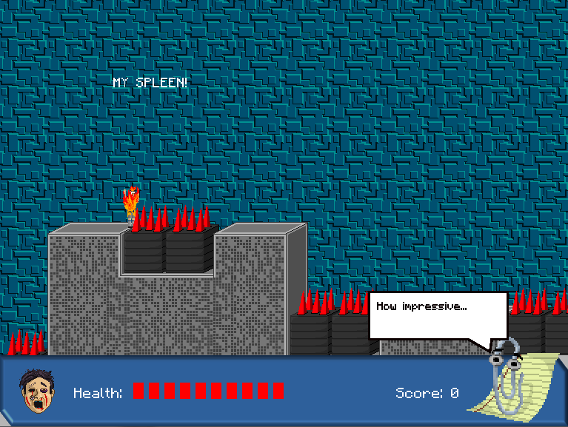Game Screens

When the player character takes damage, the health bar will empty (and become red) until he takes 10 points of damage, at which point the character will be destroyed and the level will reset.

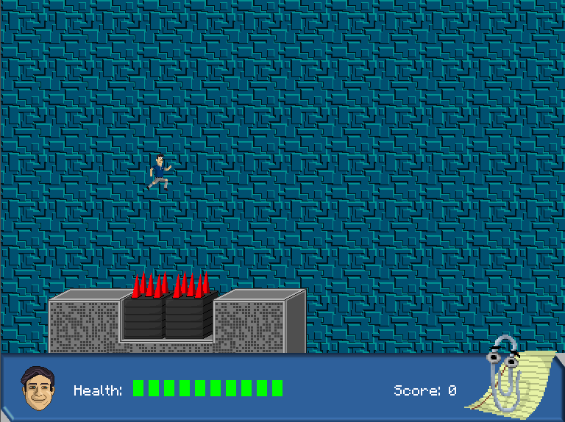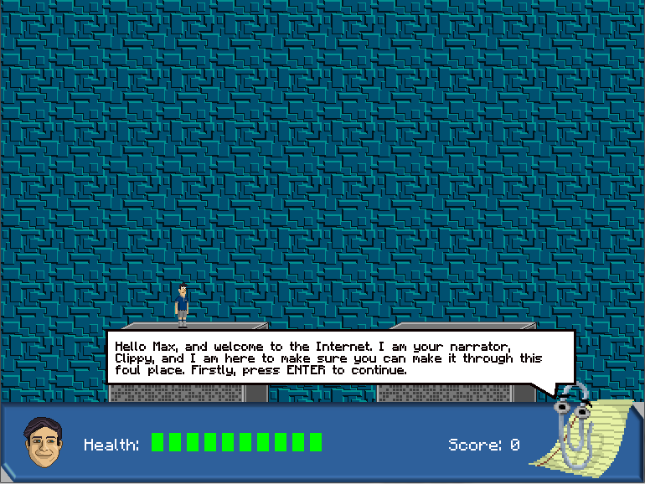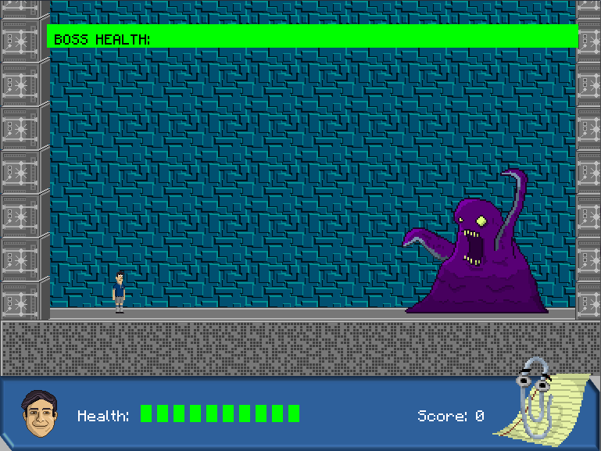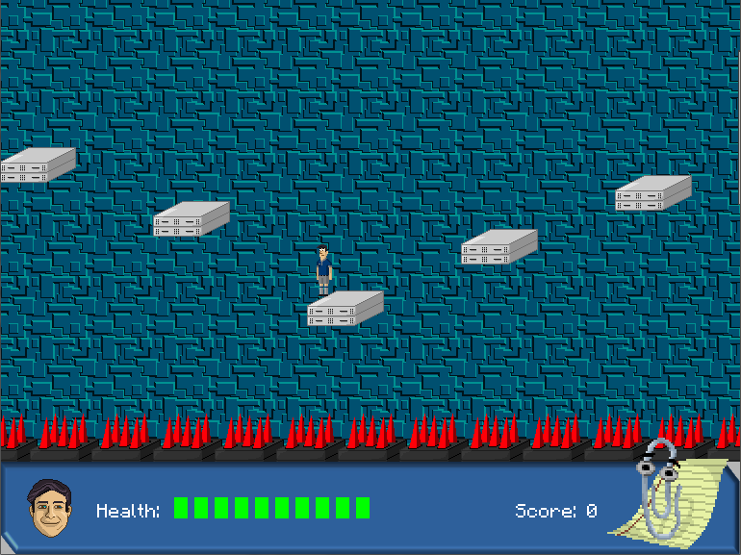

Conclusion

Overall, throughout the project our group gained useful experience in collaborative projects. Previously, most of our ICT projects have been individual games and programs, but by using the Github program, we were able to learn to collaborate and work together easily. Each team member was able to bring a different set of skills to the project, and this was found to be very useful when assigning roles for the creation of sprites, coding, level design and bug fixing. The end product is a very complex program with hundreds of lines of code. The game itself is an enjoyable, aesthetically pleasing experience, with smooth controls and interesting enemies and level design. However, if we were able to complete the project again, I would recommend that our team manage our time more effectively, as we were not able to complete the project to the extent we would have liked due to time constraints.

As we continue to develop and complete this game, we aim to accomplish several different things, both simple and complex. This includes the completion of the levels, the addition of new bosses and game elements, backing music and sound effects and some interesting mechanics along with a (hopefully) entertaining storyline that make the game more than just an ordinary platformer.

On the level design side, as we develop we aim to make the levels both interesting and challenging, but also not (unintentionally) confusing. We also believe that, as in most games, the difficulty of our levels should also increase as the player progresses throughout the game. This could involve several things, namely additional mechanics, time constraints, new enemies, harder bosses and similar mechanics.

Similarly, adding new and different enemies with challenging mechanics and interesting art is also something we believe will help the game become more interesting. Bosses are a crucial part of every game, and as we continue to improve the game, we plan on making each boss bigger and better than the last.

Finally, the finishing touches of our game will hopefully make the experience entertaining and amusing for the player. We are hoping to create our own sound effects and backing music to accompany the game, and are also considering using Flash to create cutscenes for the game to make the story more immersive for the player.

Overall, the creation of this project has allowed us to experience collaborative project design and has prepared us for a future in ICT.